[H1] Opportunities in IoT for Sustainability

[dek] How organizations use the internet of things to pursue sustainability goals

This article is part of a series on technology and sustainability.

Many organizations rely on internet of things (IoT) applications—networks of connected devices that collect, share, and process data—to monitor and reduce environmental harms, including those caused by the organizations. For researchers, IoT technologies can provide access to richer, more consistent data related to climate change and its effects on animal and plant life. These IoT applications tend to employ many of the same sensors, wireless communication methods, and data analysis techniques that help organizations streamline their day-to-day operations.

[H2] Reducing emissions
IoT is helping organizations respond to increasingly urgent demands for emissions reductions across all industries.

[H3] Detecting and fixing emissions leaks

In the oil and gas sector, some energy providers monitor and reduce their emissions using a combination of on-site wireless IoT sensors and satellite imagery. Marathon Oil uses an IoT service from Amazon Web Services that analyzes data from multiple sources to help the Texas-based energy firm locate leaks and repair equipment more quickly, cutting overall methane emissions. And in 2022, startup GHGsat used its network of six satellites to monitor 500,000 facilities for emissions and leaks. The company has so far helped companies avoid 10 million tons of emissions, or what 2.2 million cars produce in a year.

[H3] Cutting emissions through increased efficiency

AT&T has increased the energy efficiency of more than 350 of its facilities by upgrading building energy management systems with IoT equipment, and in 2021 the company started a multi-organization initiative to use IoT technologies to help its customers collectively reduce emissions by more than a gigaton by 2035. For example, construction products firm GCP is part of AT&T’s initiative and uses the company’s IoT network to maintain the consistency of concrete while it’s in transit to customers. Sensors in GCP’s mixer vehicles monitor the concrete’s status, triggering automatic adjustments to keep the material in the necessary condition for when it arrives at construction sites. This reduces the number of rejected concrete loads and the emissions from producing and redelivering those materials.

IoT can also help reduce emissions in industries not always associated with large carbon footprints. A May 2022 report from McKinsey found that as the scale of computer chip components continues to shrink, energy requirements and associated emissions will rise. As part of its pledge to reach net-zero emissions in its operations by 2040, chipmaker Intel uses IoT sensors to monitor individual pieces of manufacturing equipment in its factories. The system helps Intel head off equipment failures and increase the efficiency of its manufacturing processes, all of which contributes to less industrial emissions.

This focus on emissions reductions through greater IoT-enabled efficiency extends to other types of equipment, such as organizations’ vehicles. To help reach its goal of becoming carbon negative by 2030, Microsoft is using its own IoT solution, Microsoft Connected Vehicle Platform, to gather and analyze data about the company’s fleet of more than 500 vehicles on its Redmond, Washington campus. The system reports metrics such as idling time and fuel efficiency to a centralized IoT service, which produces optimized driving routes and maintenance schedules.

[H2] Safeguarding water resources

Climate change is affecting access to many natural resources. Some of the most urgent shortages, however, are in water for drinking, agriculture, and industrial use. A 2022 report from the University of Colorado and Colorado State University warned that climate change was taxing already strained water resources. It identified gaps in Colorado’s monitoring of its water systems. The report recommended IoT as a way of improving both efficiency and transparency: “The more data is available, the more possibility for informed decisions if data is analyzed and shared in accessible, usable ways. Digitized water—in other words, water monitored in a way that data is easily collected and utilized through connected devices that can inform human action—is technology deployed for the greater good.”
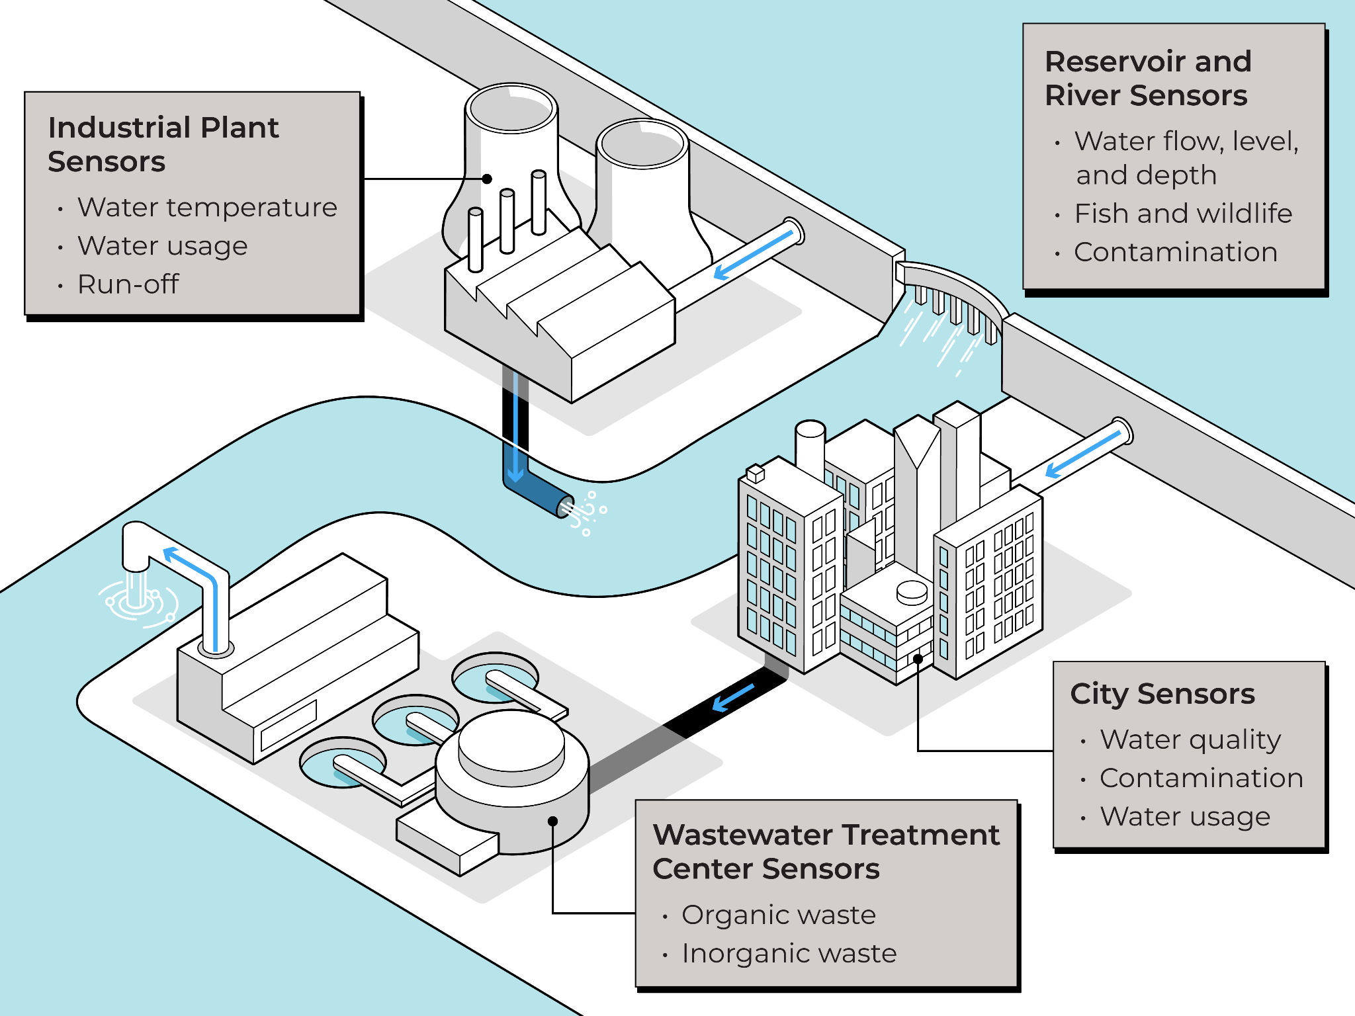
CAPTION: IoT sensors embedded in water infrastructure can deliver real-time information to regulators and plant engineers about water usage, water quality, and the presence of fish and wildlife.

Regulators like the Environmental Protection Agency use IoT sensors to monitor natural water systems such as rivers and aquifers, collecting detailed measurements of water temperature, water flow rates, and contamination levels. The data helps engineers respond to contamination incidents in rivers and lakes and know when facilities are releasing heated water into one of these natural water systems. Heated water is a common byproduct of some industrial processes and it can contribute to algae blooms that cause die-offs in fish, bird, and plant species.

IoT applications can also help organizations avert future threats to water resources. Sensor data from dams, reservoirs, and treatment facilities provides climate researchers and municipalities with a real-time picture of water usage and early warning of leaks or other issues that could restrict water supplies. For instance, over-pressurization can break a water pipe or pressure valve, wasting water as well as the energy used to transport it. IoT data allows organizations to react quickly to these incidents and prevent more severe outcomes.

Seattle City Light, the city’s public utility which operates several hydroelectric dams in Washington, combined aerial imagery and water consumption data collected with an IoT system to build a digital twin, or virtual representation, of the real-world behavior of the Diablo Dam. Engineers use the digital twin to compare current conditions at the dam—including water pressure readings from piezometers—with historical data to anticipate future issues, such as damage caused by how the structure is shifting with the surrounding land.

[H2] Monitoring wildlife and plant life

By providing real-time information about the environment, IoT systems can help organizations make informed decisions that limit harms to wildlife and plants in local ecosystems. In rarer cases, IoT can also assist efforts to make environments more sustainable.

[H3] Limiting harms to endangered marine life
An IoT system developed by the Pacific Northwest National Laboratory uses submersible microphones to detect tagged fish, such as endangered salmon, that are passing through hydroelectric dams. The sensors are paired with wireless transmitters and can send a compressed copy of the data every hour to a server in the dam facility. During seasons when mature salmon are passing through river systems for spawning, dam operators use this data to throttle the flow of water running through the system to reduce stress on the fish.

Ship operators such as Maersk, Evergreen, and Chevron use data from an IoT system called Whale Safe to reduce the risk of collisions with Blue Whales and other endangered species in the San Francisco Bay Area and the Santa Barbara Channel. Whale Safe uses buoys with microphones to detect the presence of whales in regions with shipping lanes, alerting vessels to slow down.
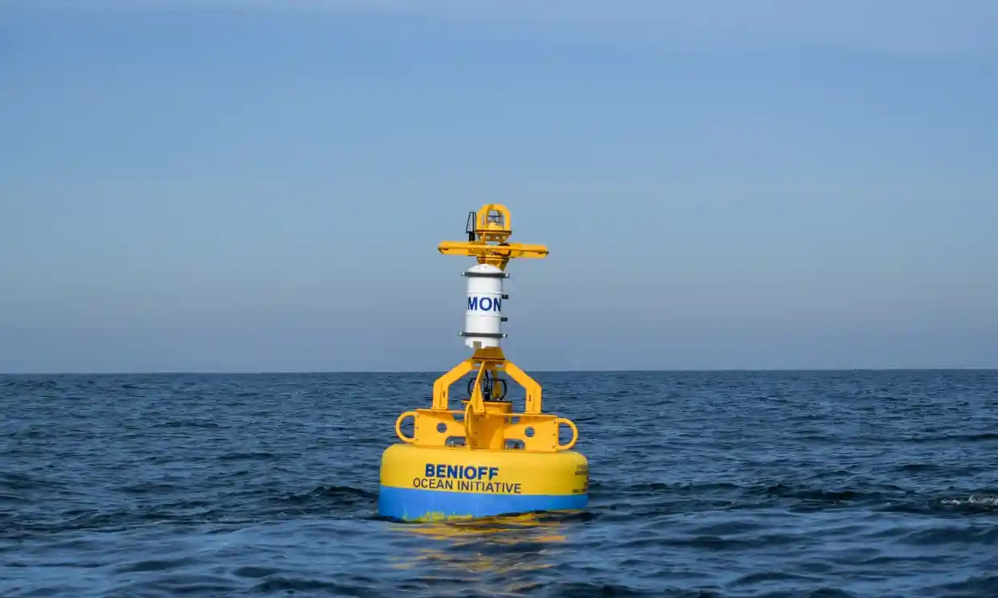
CAPTION: The Whale Safe project uses whale vocalizations picked up by sensor buoys (above) and visual sightings logged on a mobile app to inform shipping companies about likely whale activity in an area. Photo by Bekah Lane © The Marine Mammal Center. Used with permission.

[H3] Fostering sustainable plant growth

Climate scientists are using IoT technology to better understand the ability of forests to draw carbon dioxide from the atmosphere. Researchers with Forest Research, a UK government agency, have fitted trees in two forests in England with IoT sensors. The wireless devices detect soil temperature and moisture and measure the current girth of the trees to within a millimeter—a key indicator of their carbon dioxide absorption. In an interview about the research project, Matthew Wilkinson, a climate scientist with the Forest Research agency, described the benefits of IoT systems over traditional monitoring methods, such as barometers that are set to record air pressure and must be retrieved later. “Data loggers are occasionally stolen, they can stop working inexplicably and vermin can chew through their data cables,” Wilkinson said. “Teams of surveyors are needed to copy the information off the data loggers, but working alone in remote areas has health and safety issues which we must think about … IoT should be able to do it all in real time, at less cost.”

Researchers are also exploring IoT applications that make farming more sustainable. IoT4AG, a research center sponsored by the National Science Foundation, is collaborating with industry partners, such as Bayer, John Deere, and Soiltech Wireless to conduct pilot studies to evaluate IoT systems that monitor the watering needs of corn, wheat, almonds, and other crops. “We want to improve sensing capabilities so that we know when to water or not, and want to know that in time and space,” IoT4AG director Cherie Kagan tells MIT Horizon. Having accurate measurements of factors such as soil compaction, humidity, and concentration of fertilizers can help farmers use resources more efficiently, and more sustainably. IoT4AG is also testing new IoT sensors made from biodegradable materials. “We are looking at substrates made of paper and at 3D printing sensors that can entirely degrade,” says Kagan. “You already find these materials in your soil—they won't cause a problem.”

Learn more
- How IoT works
- The benefits of IoT
- A glossary of common sustainability terms

